#vim /etc/procmailrc //create file

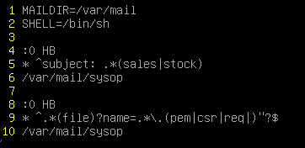

#vim /etc/mail/sendmail.mc







# sendmailconfig //re-create .cf file